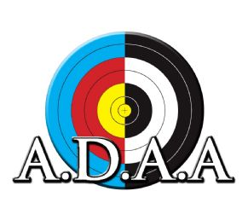
The Auckland District Archery Association presents:
District Doubles Trophy Challenge
29 June 2019

Are you a husband and wife that shoot together? Parent and child? Siblings? Best friends?
Do you think you have what it takes to beat other pairs in the district? Are you prepared to work together to win the coveted District Doubles trophy?
Come along to Mountain Green Archery Club on Sunday 29 June (rain date July 6) with your parent/partner/buddy and shoot for the trophy. To level the playing field, Auckland District is providing all bows and arrows – beginner’s wooden and plastic recurves (no sights) will be used.
If you have your own wooden or plastic recurve you’d like to bring along, let us know. You will be required to take the sight off.
Bring your own armguards/finger-tabs if you have them, otherwise it will be provided for you.
$10 per team

Schedule:
9am Muster and Equipment Assignment
9.30am Start Shooting
(Short Queen Adelaide Round: 122cm target, 36 arrows at 30m & 20m)
12.30pm Lunch (Fundraising BBQ will be on site) and fun event
1.30pm Match Play for the Trophy
Approx. 4pm Prize-Giving
Medals will be won by the top three teams, with the Trophy to the winning team.

ENTRY FORM:

Team Name:
Team Member #1:
#1 handedness (left/right):
Team Member #2:
#2 handedness (left/right):
Relationship to each other: (eg parent/child):
Contact Mobile:
Email:
Club:
Bringing own bows? Yes/No
Bows MUST be wooden or plastic recurves. No aluminium or carbon riser types are permitted.

Entry fee: $10 per team
Entries to: adaa.secretary@gmail.com
Entries must be in by 20 June 2019. Entries will be confirmed once payment is received.
Payment Details: Bank account number 12-3629-0108565-00, please use your surname as reference and “ADAA DOUBLES” in the details.
Cash on the day is also accepted but please let us know when you enter.
Venue: Mountain Green Archery Club, Mount Albert. Remember to park at the gates and walk in.

